# **Structured vs Unstructured Data:**

## **Structured Data**

refers to data that resides in a fixed field within a file or record. Structured data is typically stored in a relational database (RDBMS) and can consist of numbers and text. Sourcing can happen automatically or manually, as long as it's within an RDBMS structure. It depends on the creation of a data model, defining what types of data to include, and how to store and process it.

The programming language used for structured data is [SQL](https://www.integrate.io/blog/the-sql-vs-nosql-difference/) (Structured Query Language). Developed by IBM in 1974, SQL handles relational databases and doesn’t require advanced coding skills.

Typical examples of structured data are names, addresses, credit card numbers, numerical data, Microsoft Excel files, text files, and so on.

## **Unstructured Data**

is all the data that is not structured. Even though unstructured data may have a native, internal structure, it's not structured in a predefined way. There is no data model; the data is stored in its native format.

Typical examples of unstructured data are rich media, text, social media activity, video files, audio files, surveillance imagery, and various other file formats.

The amount of unstructured data is much larger than that of structured data.

**in nature and sometimes stored in a non-relational database or NO-SQL.**

## **Comparison of Structured vs Unstructured Data :**

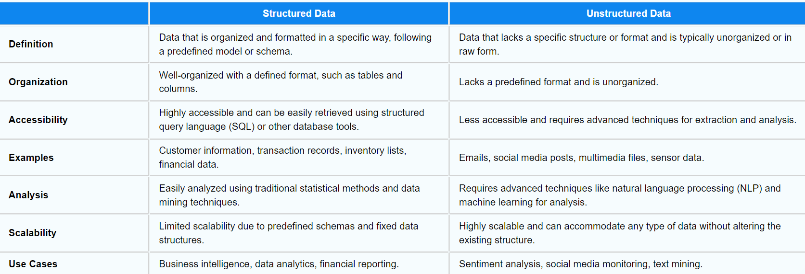

Resources :

<https://www.javatpoint.com/structured-data-vs-unstructured-data>

<https://www.integrate.io/blog/structured-vs-unstructured-data-key-differences/>